 | Grenze journal name, Volume. 1, Issue.1, May 2015

A Comparative Study of Power BI and Tableau Through Sales Insights Dashboard Implementation

Author¹, Author² and Author³
¹ Name of Institution/Department, City, Country
Email: first.author@hostname1.org
²⁻³ Name of Institution/Department, City, Country
Email: {second.author, third.author}@hostname2.org

Abstract—In today’s competitive business environment, real-time access to data-driven insights is critical for effective decision-making. AtliQ Hardware, an India-based supplier of computer hardware and peripherals, faced significant challenges in monitoring regional sales performance. The company’s sales director had to rely on verbal reports from regional managers, which lacked consistency, clarity, and data-backed evidence—ultimately leading to frustration and poor strategic decisions amid declining overall sales.
To address this, a comprehensive sales insights dashboard was developed using two leading Business Intelligence (BI) tools—Power BI and Tableau. This study presents a practical comparison of these tools based on a step-by-step implementation of dashboards. In Power BI, detailed modules such as key performance indicators, profit analysis, and overall performance tracking were developed. In Tableau, visualizations were created focusing on revenue and profit analysis. The comparison explores various factors such as data connectivity, ease of use, visualization capabilities, performance with small and large datasets, and implementation complexity.
Results reveal that Power BI, with its seamless Microsoft ecosystem integration and cost-effectiveness, is well-suited for small to medium datasets and quick deployment. Tableau demonstrates superior handling of large datasets and offers advanced customization, albeit with a steeper learning curve and higher costs. Based on these findings, the study offers recommendations for organizations on selecting the appropriate BI tool depending on their business needs, technical expertise, and data infrastructure.

Index Terms—Power BI, Tableau, Buisiness Intelligence (BI), Data Visualization, Real-time Insights, Comparative Study.
I. Introduction
In today's fast-paced business environment, organizations are increasingly relying on data-driven decision-making to remain competitive and achieve sustainable growth. Business Intelligence (BI) tools have become essential in this transformation, enabling businesses to turn raw data into valuable insights. These tools not only enhance the decision-making process but also provide greater visibility into key performance metrics and improve operational efficiency.
AtliQ Hardware, an India-based supplier of computer hardware and peripherals, operates through multiple regional offices, with its headquarters located in Delhi. The company serves a diverse client base across India, including well-known retail chains such as Surge Stores and Nomad Stores. Despite having a wide distribution network, AtliQ Hardware’s method of monitoring sales performance was limited to verbal communication between the sales director and regional managers. This informal approach led to inconsistent reporting, a lack of transparency, and an incomplete understanding of regional sales trends. The absence of a centralized, data-driven reporting system made it challenging for the sales director to identify key problem areas and make informed decisions, especially as overall sales began to decline.
To address these challenges, this research explores the implementation of interactive sales dashboards using two widely adopted BI tools: Power BI and Tableau. The main objective is to enable the company to monitor sales performance in real-time, providing stakeholders with actionable insights and supporting strategic decision-making.
In this study, a comprehensive sales insights dashboard was developed in Power BI, incorporating modules such as key performance indicators (KPIs), overall performance tracking, and profit analysis. A parallel implementation in Tableau was also carried out to analyze revenue and profit performance. By comparing both tools, this paper examines their usability, data connectivity, visualization capabilities, implementation flexibility, and performance when handling both small and large datasets.
The purpose of this research is not only to demonstrate the technical process of developing these dashboards but also to offer a detailed comparative analysis of Power BI and Tableau. This analysis aims to help organizations select the most suitable tool based on their specific needs, scale, and technical capabilities.
The structure of this paper is as follows: Section II provides a review of related work and an overview of the selected BI tools. Section III details the methodology and step-by-step dashboard development process. Section IV presents the comparative analysis and key findings. Finally, Section V concludes with insights and recommendations for future use.

Grenze ID: 01.JMMB.1.1.23
© Grenze Scientific Society, 2015

II. Literature Review
Sales insights in a hardware supply company were analyzed using Power BI, highlighting its real-time data visualization and user-friendly environment for enterprise use [1]. The ETL pipeline involved SQL for extraction, Power Query for transformation, and DAX for modeling, providing a framework for better strategic decision-making, though Tableau was not part of the study. Further research emphasized Power BI's interactive capabilities and its use of MySQL data, Python-based cleaning, and a star schema design for optimal query performance [2]. Drill-down dashboards and real-time analytics made it effective for business insights. An extensive integration of sales, finance, marketing, and supply chain data through Power BI created multidimensional views for forecasting and performance tracking [3]. CRM systems and other data sources were unified to enable better decision-making. Another study combined SQL pipelines with Power BI dashboards to monitor Atliq Hardware’s regional sales and inventory levels in real-time [4]. Key insights included 35% sales in the Northeast and a 20% decline due to low inventory, showing the importance of synchronized data and visual KPIs. Research by Banerjee et al. (2024) demonstrated that calculated columns and DAX formulas in Power BI improved strategic business planning through real-time dashboards and unified data views [5]. The Quick Insights feature in Power BI was used to automate reporting and minimize human error, especially during and after the COVID-19 era, showing its impact on business intelligence growth and mobile BI adoption [6]. A comparative study showed that Power BI offers cost efficiency and seamless Microsoft integration, which benefits non-technical users, while Tableau is suitable for advanced analytics and highly customized dashboards used by larger enterprises [7]. Another work compared BI tools to Data Science methods, concluding that Power BI excels in intuitive visualization and strategic planning, while machine learning in data science supports trend prediction [8]. Scalability and user-friendliness made Power BI and tools like Google Analytics increasingly popular, despite some integration and compatibility challenges.

III. Methodology

A. Workflow with Comparative Evaluation

To address the limitations found in existing literature—particularly the lack of tool-to-tool comparison and narrow organizational focus—this study adopts a comprehensive, dual-platform methodology using Power BI and Tableau. Each phase of the process includes a performance and efficiency comparison of the BI tools involved in the step-by-step process.
1) Data Discovery:
Business questions were formulated using the AIMS Grid framework to ensure alignment with strategic decision-making objectives across sales, operations, and finance. This step was not confined to a single organizational context like AtliQ Hardware, thereby enhancing the generalizability of the study.
It is a project management tool which consists of four components-
- Purpose - (What to do exactly)
- Stackholder - (Who will be involved)
- End result - (What do you want to achieve)
- Success Criteria - (Cost optimization and time save)
2) Initial Data Analysis using MySQL:
A. Workflow with Comparative Evaluation
To address the limitations found in existing literature—particularly the lack of tool-to-tool comparison and narrow organizational focus—this study adopts a comprehensive, dual-platform methodology using Power BI and Tableau. Each phase of the process includes a performance and efficiency comparison of the BI tools involved in the step-by-step process.
1) Data Discovery:
Business questions were formulated using the AIMS Grid framework to ensure alignment with strategic decision-making objectives across sales, operations, and finance. This step was not confined to a single organizational context like AtliQ Hardware, thereby enhancing the generalizability of the study.
It is a project management tool which consists of four components-
• Purpose - (What to do exactly)
• Stackholder - (Who will be involved)
• End result - (What do you want to achieve)
• Success Criteria - (Cost optimization and time save)
2) Initial Data Analysis using MySQL:
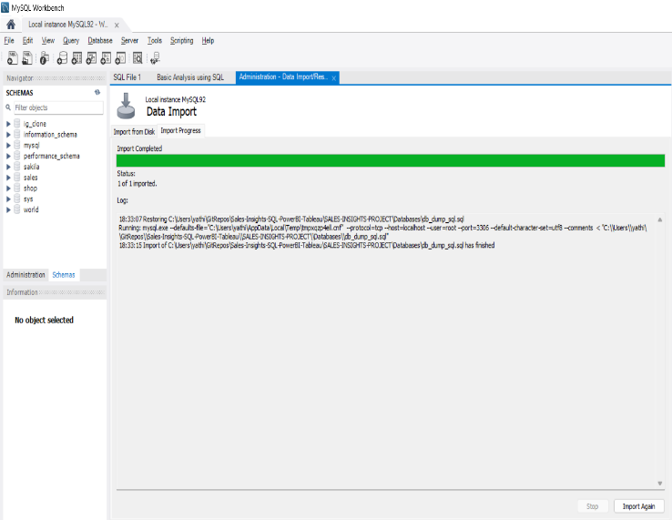
The sales dataset used in this study was sourced from a publicly available GitHub repository, ensuring transparency and reproducibility. A database dump file (db_dump_sql.sql) was imported into MySQL Workbench, providing structured access to multiple interrelated tables such as customers, products, transactions, date, and markets. Initial SQL queries identified key data quality issues, including invalid market codes, negative transaction values, and inconsistent currency formats (e.g., USD instead of INR). These were addressed through SQL-based cleaning and transformations. The processed dataset was then prepared for seamless integration into Power BI and Tableau for further analysis and dashboard development.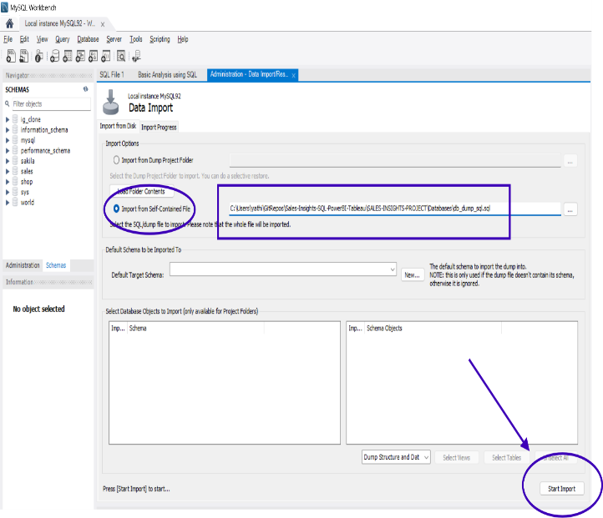
2) Data Cleaning and ETL:
Power Query was used to transform and load raw data into a structured format suitable for analysis. The process was designed to be compatible with both Power BI and Tableau, avoiding tool-specific constraints found in previous studies..
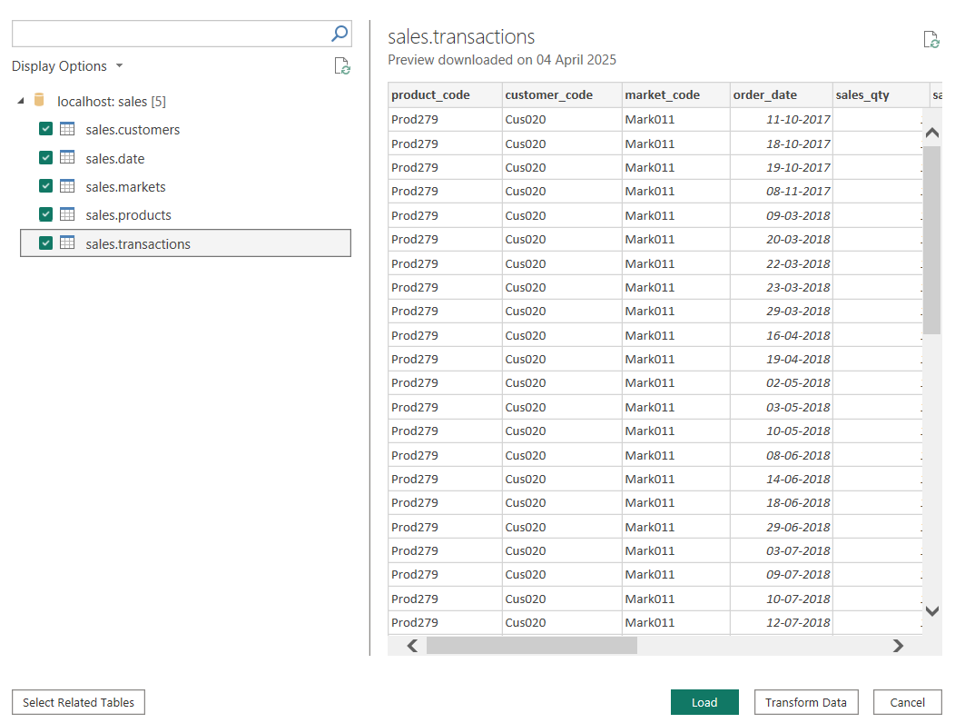
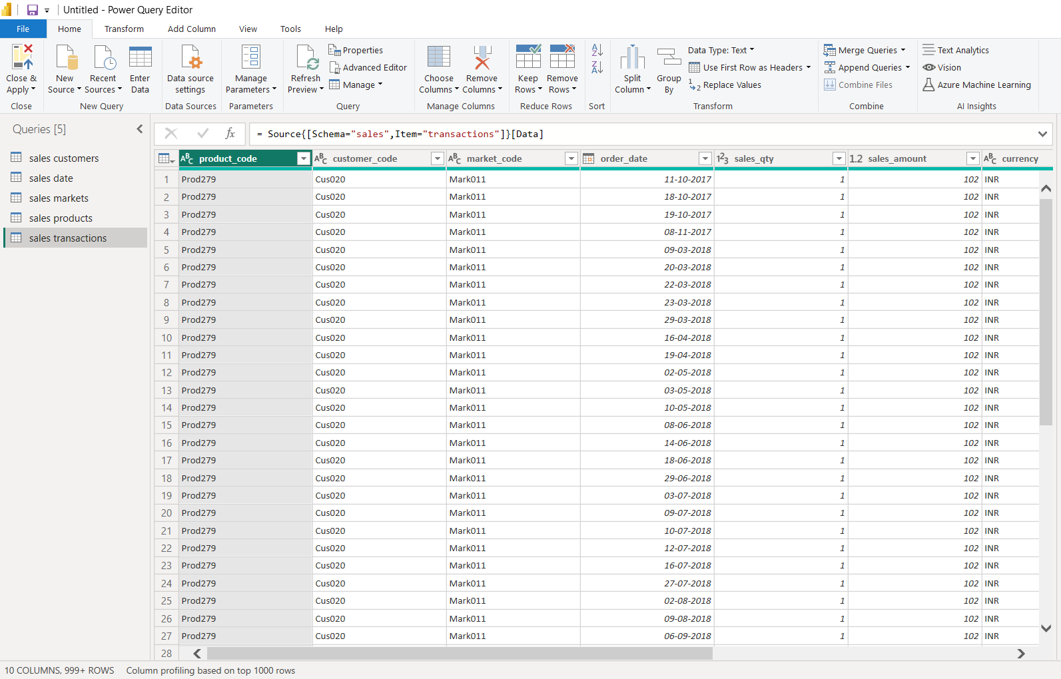

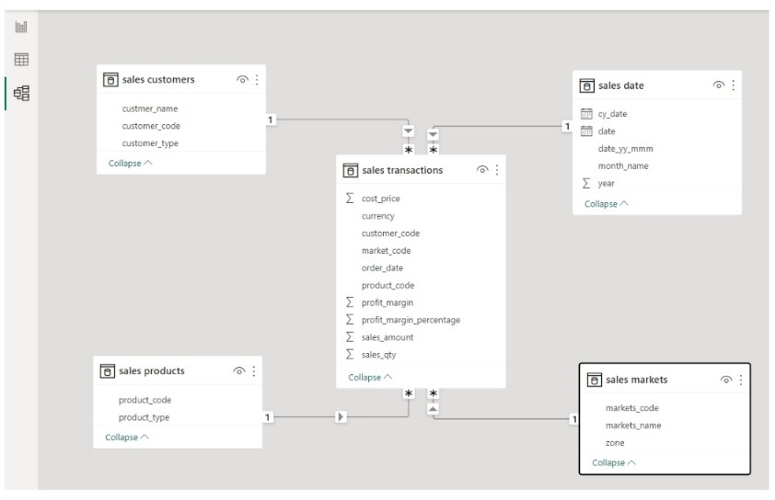
4) Data Modeling:
Star schema models were created to optimize performance and support drill-down analytics. This structure enhanced responsiveness and analytical depth across both platforms.
A comparison was made on schema adaptability, performance during large data queries, and modeling complexity within each tool.
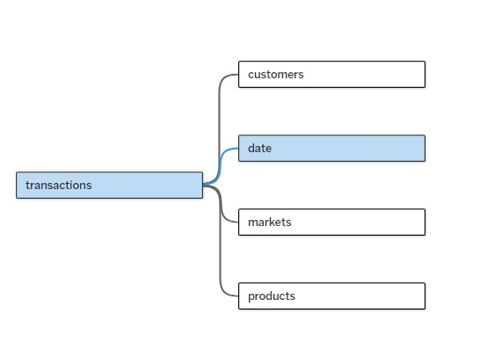
5) Data Analysis (DAX):
In Power BI, DAX formulas and KPIs were implemented to extract meaningful performance metrics. Equivalent calculations and measures were replicated in Tableau using calculated fields and LOD (Level of Detail) expressions.
- Profit Margin % = DIVIDE([Total Profit Margin],[Revenue],0)
- Profit Margin Contribution % = DIVIDE([Total Profit Margin],CALCULATE([Total Profit Margin],ALL('sales products'),ALL('sales customers'),ALL('sales markets')))
- Revenue = SUM('sales transactions'[sales_amount])
- Revenue Contribution % = DIVIDE([Revenue],CALCULATE([Revenue],ALL('sales products'),ALL('sales customers'),ALL('sales markets')))
- Revenue LY = CALCULATE([Revenue],SAMEPERIODLASTYEAR('sales date'[date]))
- sales quntity = SUM('sales transactions'[sales_qty])
- Total Profit Margin = SUM('Sales transactions'[Profit_Margin])

6) Dashboard Development:
Fully interactive dashboards were developed in both Power BI and Tableau, incorporating KPIs, filters, visual charts, and regional performance insights.
This final stage included a side-by-side comparison of visualization capabilities, user interface experience, customization options, and performance with small vs. large datasets.
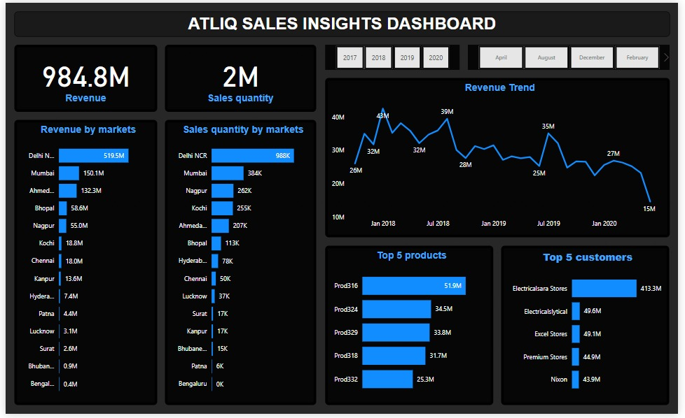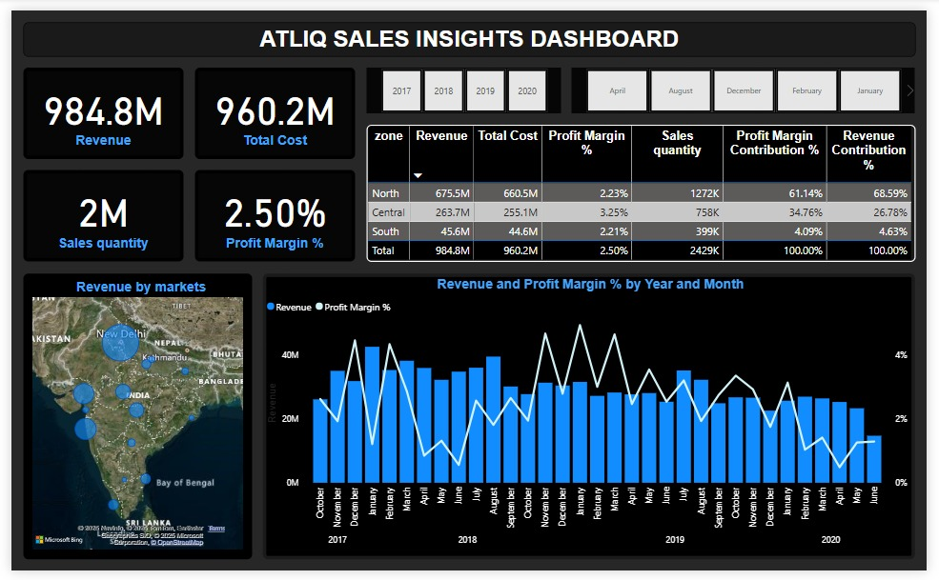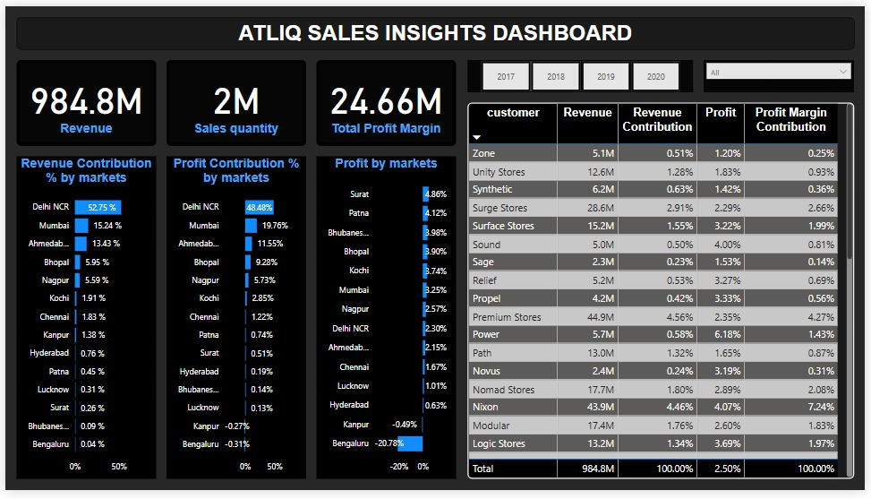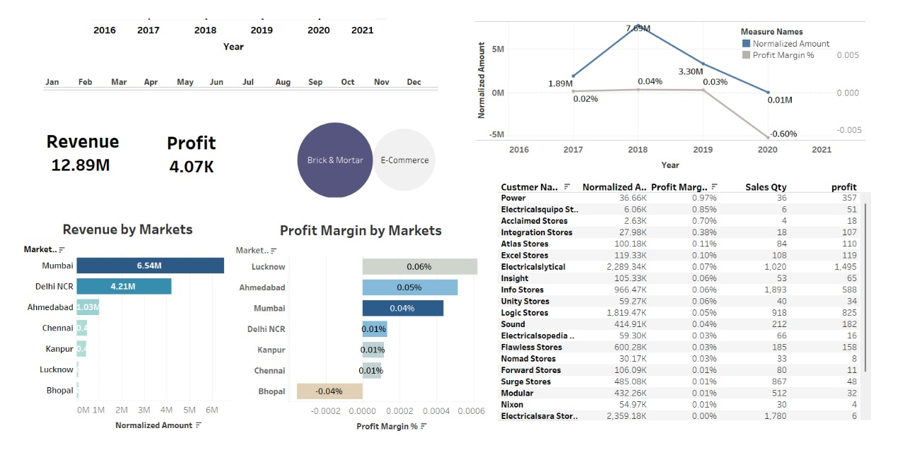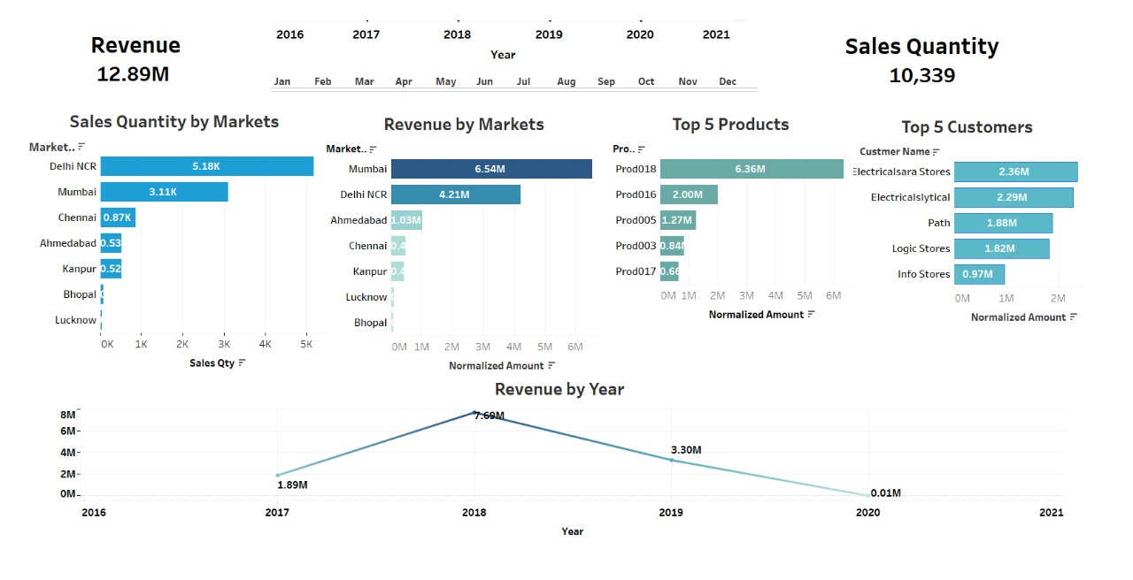

III. Conclusions
Real-time data visualization enhances decision-making and business strategy. Power BI is user-friendly and well-suited for small to medium datasets, especially within Microsoft ecosystems. Tableau handles large datasets and offers advanced visualizations but comes with higher cost and complexity. The choice between the two depends on data volume, business needs, and user expertise. With either tool, an effective dashboard can greatly improve sales tracking and performance insights.

References

- Bhange, A.D., Patel, A.S., Durgam, R., Ihare, S., Kapsikar, S., Katre, A.: E-GOVGUARD EGG: Sales Insights Data Analysis in Power BI. In: International Journal of Progressive Research in Engineering Management and Science (IJPREMS), Vol. 04, Issue 05 (2024) 1887–1890

- Tehreen, T.T., Thanuja, J.C.: Power BI Sales Intelligence. In: International Advanced Research Journal in Science, Engineering and Technology, Vol. 11, Issue 7 (2024) 312.

- Das, S., Banerjee, K., Nath, S., Chatterjee, S.: Data Visualization Approach for Business Strategy Recommendation Using Power BI Dashboard. In: International Journal of Latest Engineering Science (IJLES), Vol. 06, Issue 05 (2023).

- Chopra, E.K., Mehra, J., Gaurav, A., Chauhan, A.: Sales Insights: Extracting Value From Hidden Data. In: IEEE

- Banerjee, K., Das, S., Nath, S.: Data Visualization Approach for Business Strategy Recommendation Using Power BI Dashboard. In: International Journal of Research in Management (IJRM), Vol. 6, Issue 1 (2024) 168–175.

- Singh, S., Jadhav, L.: Data Analysis and Visualization of Sales Dataset Using Power BI. In: International Journal for Research in Applied Science and Engineering Technology (IJRASET), Vol. 10, Issue VI (2022) 13.

- Kumar, V., Vashisht, P.: A Comparative Study of Data Analytics Tools: PowerBI vs. Tableau. In: Journal of Emerging Technologies and Innovative Research (JETIR), Vol. 12, Issue 1 (2025) a975.

- Sharma, K., Jain, A., Shetty, A., Dhanare, R.K.: A Comparative Analysis on Various Business Intelligence (BI), Data Science and Data Analytics Tools. In: Proceedings of the 2021 International Conference on Computer Communication and Informatics (ICCCI-2021), Jan. 27-29, 2021, Coimbatore, India.

